Project Design Phase-II
Technology Stack (Architecture & Stack)

Date | 1 October 2026
Team ID | SWTID-2026-5148
Project Name | Implement Client Script & UI Policy (Incident)
Maximum Marks | 4 Marks
Team: Mathangi S (Team Leader), Meena Varshini T P, Mirthika R, Muthu Priya U | Team Size: 4
Technical Architecture:
The Deliverable shall include the architectural diagram as below and the information as per the table1 & table 2
Architecture: Client-side validation of Incident records in ServiceNow

Architecture Notes:
Client tier: Incident form, UI Policy and 3 Client Scripts
Platform tier: ServiceNow cloud instance
External APIs: none used
Data store: Incident table
Machine learning: not applicable
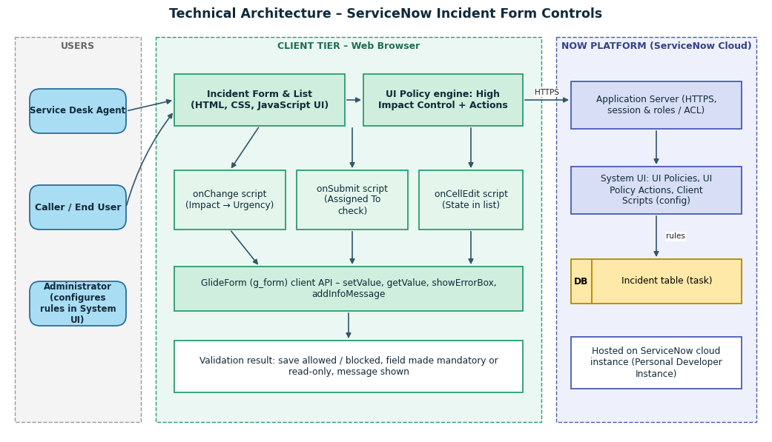

Table-1 : Components & Technologies:
S.No | Component | Description | Technology
 | User Interface | How the agent interacts with the application: Incident form and list | ServiceNow Incident form / list (HTML, CSS, JavaScript rendered by the platform)
 | Application Logic-1 | UI Policy "High Impact Control": makes Assignment group mandatory and Urgency read-only when Impact = High | UI Policy and UI Policy Actions (System UI)
 | Application Logic-2 | onChange Client Script: sets Urgency to High when Impact becomes High | JavaScript – GlideForm (g_form) API
 | Application Logic-3 | onSubmit Client Script: blocks save when Assigned To is empty for High impact | JavaScript – g_form.showErrorBox
 | Application Logic-4 | onCellEdit Client Script: blocks State edits made from the list view | JavaScript – onCellEdit callback
 | Database | Incident table (task-based records) storing Impact, Urgency, Assignment group, Assigned To, State | ServiceNow relational database (managed by the platform)
 | Cloud Database | Database service hosted in the ServiceNow cloud | ServiceNow cloud instance
 | File Storage | Not required for this project | Not applicable (platform attachment storage available)
 | External API-1 | Not used; the solution is entirely platform-native | Not applicable
 | External API-2 | Not used | Not applicable
 | Machine Learning Model | Not used | Not applicable
 | Infrastructure (Server / Cloud) | Application deployment on a cloud-hosted ServiceNow instance; Cloud Server Configuration: managed by ServiceNow | ServiceNow Personal Developer Instance / cloud instance

Table-2: Application Characteristics:
S.No | Characteristics | Description | Technology
 | Open-Source Frameworks | No custom open-source framework; uses native ServiceNow low-code features | ServiceNow platform (JavaScript client API)
 | Security Implementations | Role-based access, authenticated sessions over HTTPS; configuration limited to admin roles; client validation to be backed by server-side rules in future | ServiceNow roles / ACLs, HTTPS
 | Scalable Architecture | Multi-tier platform (browser, application server, database); rules defined once on the table apply to all records | ServiceNow multi-tier cloud platform
 | Availability | Cloud-hosted instance; availability handled by the ServiceNow platform | ServiceNow cloud
 | Performance | Validations run in the browser with lightweight scripts, avoiding extra server calls | Client-side JavaScript, UI Policy

References:
https://c4model.com/
https://developer.ibm.com/patterns/online-order-processing-system-during-pandemic/
https://www.ibm.com/cloud/architecture
https://aws.amazon.com/architecture
https://medium.com/the-internal-startup/how-to-draw-useful-technical-architecture-diagrams-2d20c9fda90d

